**mflash User Guide如何采用mflash下载设备固件**

Neo

# Version

|  |  |  |  |
| --- | --- | --- | --- |
| Version | Date | Author | Note |
| v1.0 | 16/04/2020 | Neo | Initial version |
|  |  |  |  |

Content

Version 1

1、Introduction 0

2、Install mflash 0

2.1、Install mflash 0

3、Download firmware with mflash 0

3.1 Support Modules 0

3.2 Download Firmware 0

# 1、Introduction

mflash is a firmware download tool developed by MXCHIP, which is used for developers to download firmware conveniently by using JLINK.

At present, the chip of modules supporting firmware download using mflash are: mx1290, mx1270, mx1300, mx1310, mx1350

# 2、Install mflash

## 2.1、Install mflash

Run mflash-setup-0.1.0.exe and install

# 3、Download firmware with mflash

## 3.1 Support Modules

Support module:

|  |  |  |
| --- | --- | --- |
| Chip | Module | Download method |
| MX1270 | EMW3070 | jlink_swd |
| EMW3072 |
| MX1290 | EMW3080/EMW3080V2 | jlink_swd |
| EMW3090/EMW3090V2 |
| MX1300 | EMC3080 | jlink_swd |
| MX1310 | EMC3280 | jlink_swd |
| EMC3380 |

## 3.2 Download Firmware

1. **Download with jlink_swd:**

The JLink Debugger (V8 or V9) is currently supported on all hardware platforms supported by mxos. On macOS, Linux platform, Jlink can be used after connecting to the USB interface of the PC. The installation steps under Windows are as follows:

1. Connect Jlink to PC, default driver shown as below:

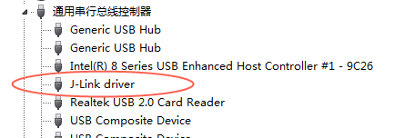

1. Download Jlink libusb driver: Jlink_Driver_for_mxos.zip，unzip and run: zadig.exe

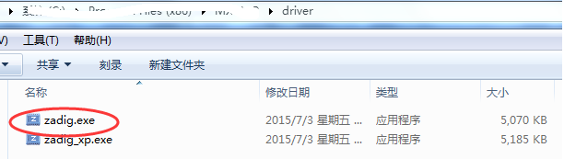

1. Select the menu: Options->List All Devices, select J-Link from the drop-down list, select “libusb-win32(v1.2.6.0)” for the driver, click “Replace Driver”, and return to “successful” to close. “libusb-win32 devices will appear in the device manager.

If you are using JLinkV8, the update process is as follows:

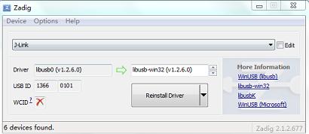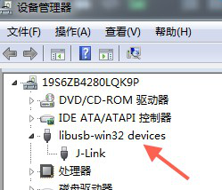

If you are using JLinkV9, the update process is as follows:

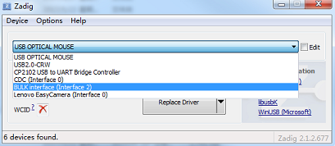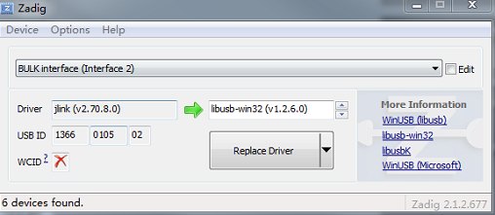

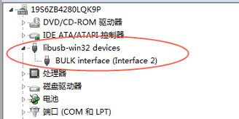

**Note: Due to different JLink firmware versions from different manufacturers, some JLink drivers may not work properly after replacing them with libusb-win32 (v1.2.6.0). In this case, try using "libusbK (v3.0.7.0)".**

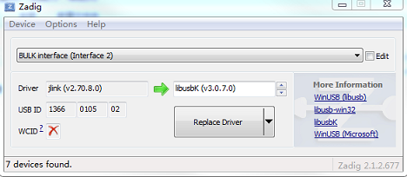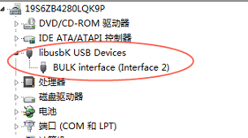

Step 2. Connect Jlink with MXkit

Open mflash, upload *.all.bin file and click write. Please select fixable debugger .If download *.all.bin，address should be 0.

Note：There should be no space in file path.

